Name____________________________________ HOMEWORK January 17-20
Put your initials by each night that your child practiced the following:

_____ Tuesday _____ Thursday

*Nightly Homework*
1. Practice saying letter names and sounds.
2. Count numbers 1-25.
3. Practice assigned Sight Word list in red reading folder.

Tuesday: Practice writing your first and last name three times, capitalizing
only the first letter of each name.

__________________________________________________________________
Practice writing each spelling word three times.

sun bus fun rug gum
________ _______ _______ _______ _______

________ _______ _______ _______ _______

________ _______ _______ _______ _______

Circle the correct final sound for each picture.

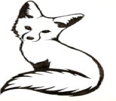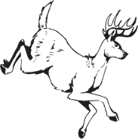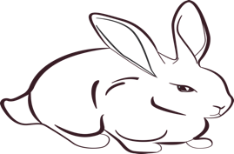
This Photo by Unknown Author is licensed under CC BY-NC-ND

r n x r d t p n s r f t

Thursday: Blend the sounds together to make a word. Write the word, then draw and color the picture for the word.

Phoneme | Phoneme | Phoneme | Write the  Word | Draw and Color the  Picture
/f/ | /o/ | /x/
/b/ | /e/ | /d/
/h/ | /a/ | /t/
/s/ | /i/ | /x/

Add a letter to the beginning of each “-un” to create a word. Read the word, then draw and color the picture for each word.

_____ un
_____ un
_____ un

Color the sight words:
for her him us jump
(red) (blue) (yellow) (green) (orange)

for | us | jump | her | him | for
her | for | him | us | her | jump
him | us | her | jump | us | him

Start Right Reader

Words to Know
for | her | jump
him | us

Go, Vic!
Bud got in his van.
But it had no gas!
Bud got up on Vic.
Bud sat on him.
“Go, Vic!”
Bud and Vic ran to the lot.
Bud got yams.
“Vic! Look! I got us yams!”
Vic got his yams. Yum!
Val got her yams. Yum!
But no yams for Bud!
Bud naps!

